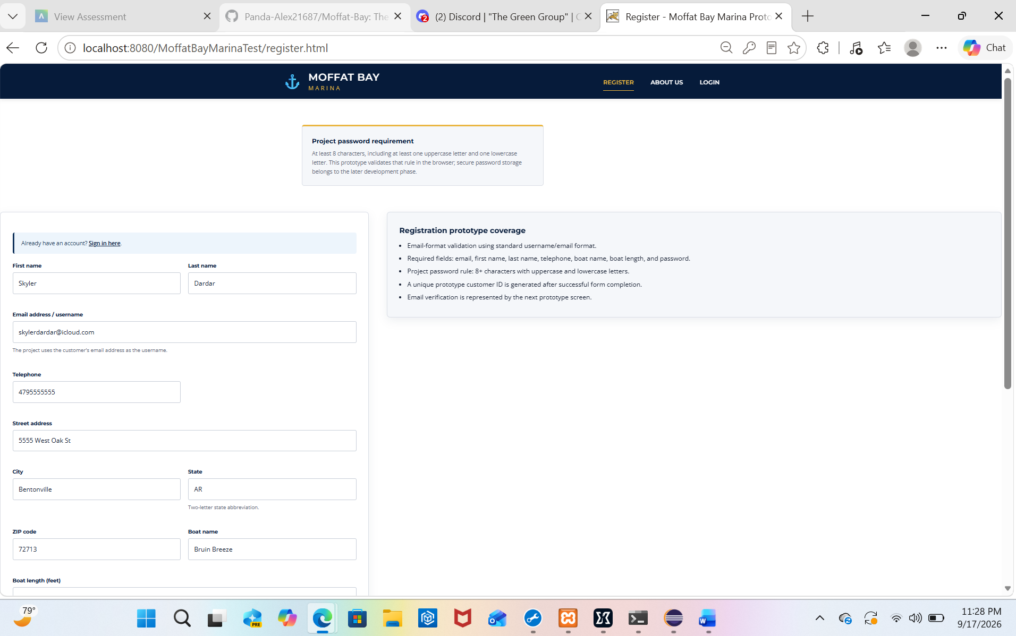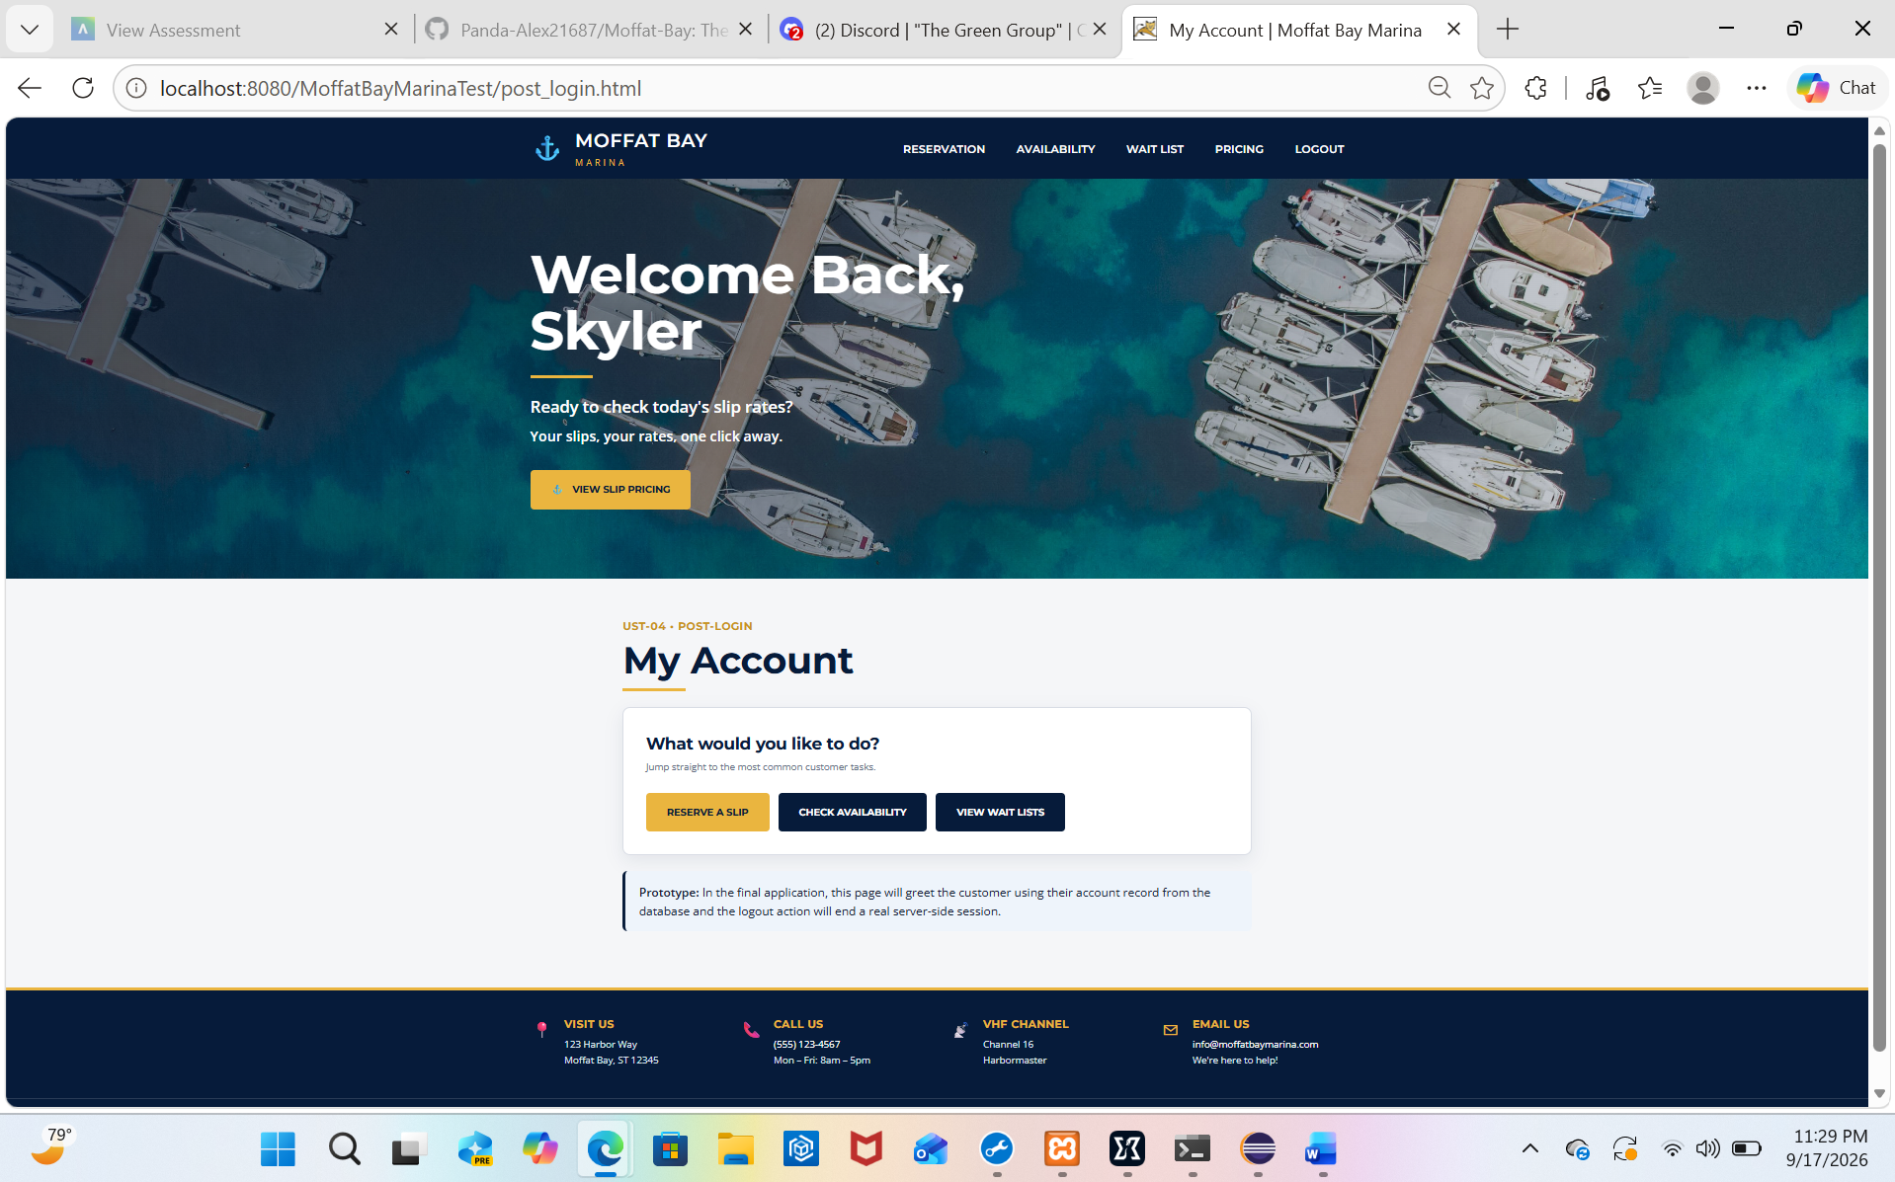

- What was your first impression of the Moffat Bay Marina website when you opened the landing page? - It was nice. Very detailed. It felt very natural and like an acutal website.

- What do you think about the website’s colors, fonts, images, and overall visual design? Why? - I really liked the blue and gold colors. Everything looked clean and the pictures fit the marina theme really well.

- Was it easy for you to find the information or page you were looking for? If not, what was difficult to find? - Yes, it was pretty easy to find everything. It was laid out in a very straight forward way.

- Were the navigation menus and buttons easy to understand and use? Were there any links or buttons that you found confusing? - Yes, the buttons and menus were easy to understand. I didn’t really run into anything confusing or out of place.

- If you were actually looking for a marina slip, was the reservation process clear and easy to follow? Why or why not? - Yes, it was easy to follow. The information it asked for made sense and the steps felt pretty simple.

- What did you like most about the website? - I liked the overall look of it and how it actually felt like a real marina website.

- What is one thing you would change or improve about the website? - I would probably make the reservation process stand out a little more so new visitors know exactly where to start.

- Did anything on the website confuse you or make you unsure about what to do next? - Not really. Once I looked around for a minute, everything was pretty easy to understand.

- Did the website look and feel professional and appropriate for a marina/resort? Why or why not? - Yes, definitely. The colors, pictures, and layout all made it feel professional and fit the marina theme.

- After using the website, would you have any suggestions that would make it easier or more enjoyable for a first-time visitor? – Not really. Maybe add some background music or something when you change tabs. Overall, I really can’t think of anything I would change myself.

